What do I need to know?
- Given a graph, identify the parent function.
- Given the equation of a function, know what the graph looks like
- Given an equation, be able to identify the domain, range, and x and y intercepts (if present).
- State the symmetry of the graph of the function. Is it even (y-axis symmetry) or odd (origin symmetry)?
- Given a real-world scenario, be able to state independent and dependent variables
- Given a real-world scenario, be able to state a reasonable domain and range.
REVIEW PROBLEMS:
- Which one of the following is the square root parent function?
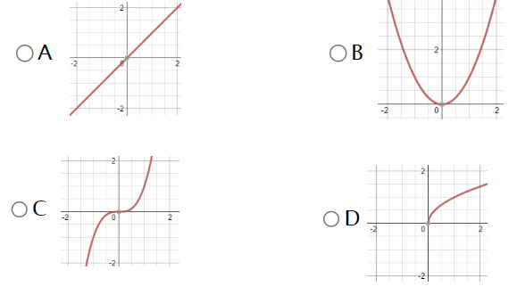

- Which one of the following is the quadratic parent function?
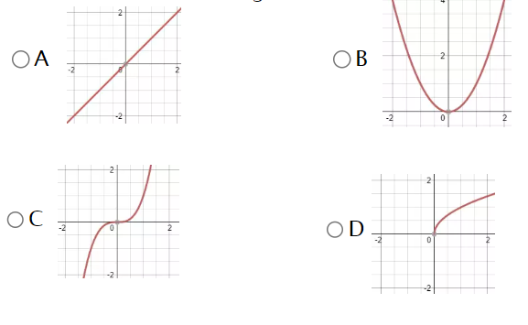

- Which of the following is the linear parent function?


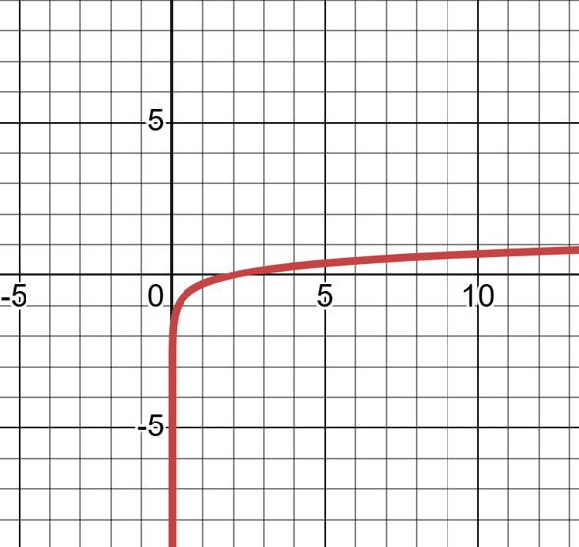
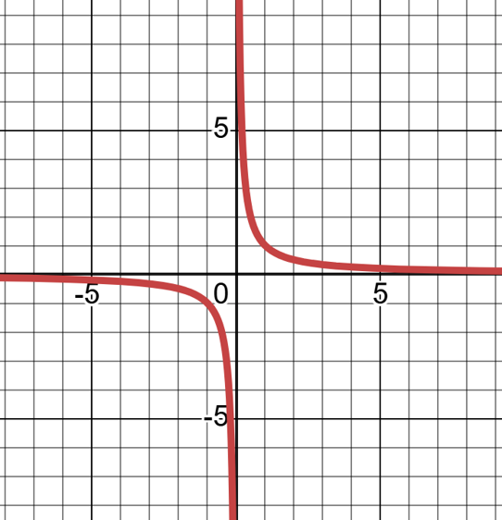
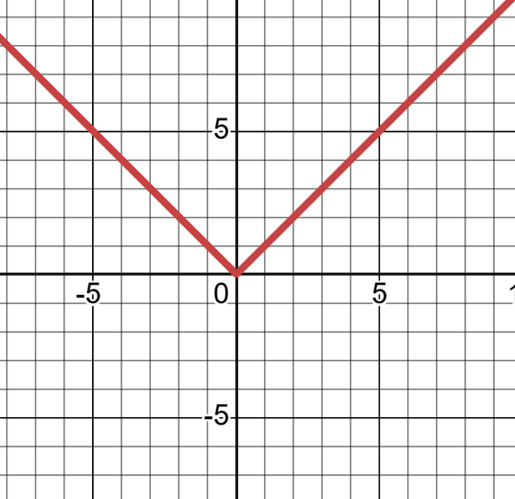
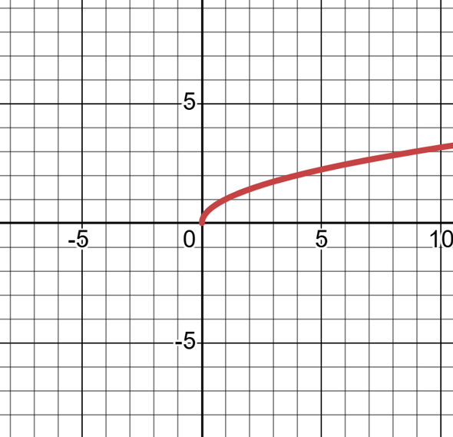
- Which of the following is the absolute value parent function?

- List the equations for all of the parent functions we are focusing on in this unit that have a domain of $x≥0$

- List the equations for all of the parent functions we are focusing on in this unit that have a range $y≥0$

- Which parent functions we are focusing on in this unit have symmetry about the origin?(Odd)

- Which parent functions we are focusing on in this unit have symmetry about the y-axis? (even)

- A phone company charges a base fee of $30 per month and an additional $0.10 for each text message sent. Let the total monthly cost be $C$ in dollars, and the number of text messages sent be $x$.
  - Identify the independent and dependent variables, and explain why.

  - State a reasonable domain and range for this situation

- The height $h$ of a sunflower (in centimeters) grows over time$t$ (in days) after it is planted. Suppose the sunflower grows at a constant rate of 2 cm per day for 50 days, then its growth slows to 0.5 cm per day for the next 30 days.
- Identify the independent and dependent variables.

- State a reasonable domain and range for this situation.

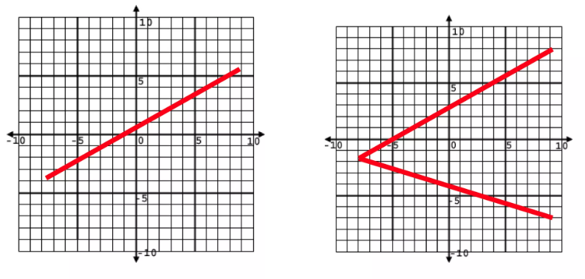
- Which one of these is not a function? Why?

- Julian, on the edge of sanity, launches his backpack up into the air from some stairs, which are 3 feet high. The graph below models the path of his backpack as it travels through the panhandle sky.
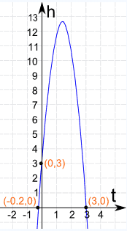
Analyze how long it takes his backpack to hit the ground.

- What does the domain represent?

- What does the range represent?

- What is a reasonable domain for the scenario?

- What is a reasonable range for the scenario?

- What are the intercepts and what do they represent in this situation?

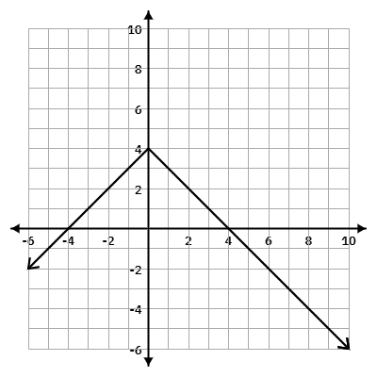
13.
Determine the following for the function:
Domain(inequality):_______________
Range (inequality): _______________
Max or Min: _______________
x-intercept: ________________
y-intercept: ________________
Parent Function Family : _______________

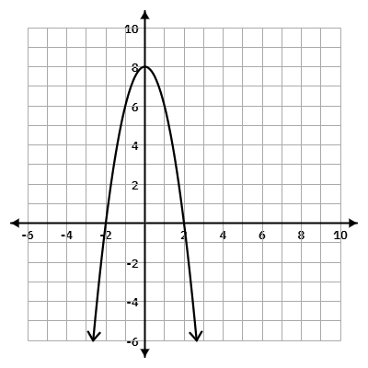
14.
Determine the following for the function:
Domain(interval):_______________
Range (interval): _______________
Max or Min: _______________
x-intercept: ________________
y-intercept: ________________
Parent Function Family : _______________

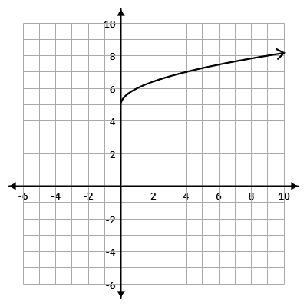
15.
Determine the following for the function:
Domain(set):_______________
Range (set): _______________
Max or Min: _______________
x-intercept: ________________
y-intercept: ________________
Parent Function Family : _______________

